### A Mini Project Report

**On**

## “Plant Disease Detection Using Deep Learning CNN Algorithms”

### SUBMITTED BY

Yash Bhandari Roll No: BECOC303

Mrunal Ingale Roll No: BECOC321

Mayur Jagtap Roll No: BECOC323

Avi Raghuvanshi Roll No: BECOC355

    Under Guidance of

**Prof. Archana Kadam**

         BE (COMPUTER ENGINEERING)

       2021-2022(Semester-II)



## DEPARTMENT OF COMPUTER ENGINEERING

PCET's Pimpri Chinchwad College of Engineering **Sector No. 26, Pradhikaran, Nigdi, Pune 411044** Savitribai Phule Pune University

2021 -2022



**PCET’S PIMPRI CHINCHWAD COLLEGE OF ENGINEERING**

Sector No. 26, Pradhikaran, Nigdi,

Pune - 411044

_________________________________________________________________________________

**DEPARTMENT OF COMPUTER ENGINEERING**

Certificate

This is to certify that the Mini Project report entitled

**“Plant Disease Detection and Using Deep Learning CNN Algorithms”**

Submitted By

Yash Bhandari Roll No: BECOC303

Mrunal Ingale Roll No: BECOC321

Mayur Jagtap Roll No: BECOC323

Avi Raghuvanshi Roll No: BECOC355

is approved by ***Prof. Archana Kadam*** for submission. It is certified further that, to the best of my knowledge, the report represents work carried out by my students as the partial fulfillment for BE. Computer Engineering (Semester II) Laboratory-IV Work (Soft Computing and Optimization Algorithm) as prescribed by the Savitribai Phule Pune University for the academic year 2021-22.

|  |  |
| --- | --- |
| Mrs. Archana Kadam |  |
| (Mini Project Guide) |  |

Place: Pune

Date:

## ACKNOWLEDGEMENT

We express our sincere thanks to our Seminar Guide ***Prof. Archana Kadam*** for his/her encouragement and support throughout our seminar, especially for the useful suggestions. We would like to thank ***Prof Dr. K. Rajeswari***. Head of Computer Engineering Department for her unwavering support during the entire course of this mini project work. We also thank all the teaching and non-teaching staff members for their help in making our seminar work successful. We also thank all the web communities for enriching us with their immense knowledge.

Yash Bhandari Roll No: BECOC303

Mrunal Ingale Roll No: BECOC321

Mayur Jagtap Roll No: BECOC323

Avi Raghuvanshi Roll No: BECOC355

ABSTRACT

Precision Agriculture has been playing a significant role in the refinement of plants' health. It ensures that crops and soil receive exactly what they need for optimum health and productivity. The term also involves minimizing pests, unwanted flooding, and disease. This paper gives a review on various plants protection and monitoring techniques. Authors mentioned here have proposed different solutions like use of drone technologies and deep learning methods. Deep learning has been playing a significant role in identifying the diseases in plants. Algorithms like VGG-net, Res- net, CNN and image processing techniques have proved to be significant in recognizing many plant diseases.

To develop a system which can detect the plant diseases as earlier as possible and notify the farmer to take the required steps for protecting the crops from getting affected. To use IOT sensors for regular monitoring of different conditions like soil water-level, humidity, temperature

|  |  |  |  |
| --- | --- | --- | --- |
| **CONTENTS** | | | |
| Sr  No. | Chapter No. | Title | Page  No. |
| 1 |  | **Introduction** | 8 |
|  | 1.1 | Motivation | 9 |
|  | 1.2 | Objective | 9 |
|  | 1.3 | Problem Definition | 10 |
| 2 |  | **Literature Survey** |  |
|  | 2.1 | Literature Review | 11 |
| 3 |  | **Project Requirements** |  |
|  | 3.1 | **Software Requirements Specification** |  |
|  | 3.1.1 | Project Scope | 14 |
|  | 3.1.2 | User Classes and Characteristics | 14 |
|  | 3.1.3 | Assumptions and Dependencies | 15 |
|  | 3.1.4 | Mathematical Modeling | 16 |
| 4 |  | **System Requirements** |  |
|  | 4.1 | Software Requirements (Platform Choice) | 17 |
| 5 |  | **Analysis Models:** |  |
|  | 5.1 | SDLC Model to be applied | 18 |
|  | 5.2 | System Architecture | 19 |
|  | 5.3 | System Design | 20 |
|  | 5.4 | UML Diagrams | 21 |
|  | 5.5 | Activity Diagram | 22 |
|  | 5.6 | Class Diagram | 23 |
|  | 5.7 | Algorithms | 24 |
| 6 |  | **Other Specification** |  |
|  | 6.1 | Advantages | 26 |
|  | 6.2 | Limitations | 26 |
|  | 6.3 | Applications | 26 |
| 7 |  | **Results** | 27 |
| 8 |  | Conclusion  References | 30 |
| 9 |  | References | 31 |

## LIST OF ABBREVATIONS

|  |  |
| --- | --- |
| **ABBREVIATION** | **ILLUSTRATION** |
| ML | Machine Learning |
| CNN | Convolutional Neural Network |
| VGG | Visual Geometry Group |
| ResNet | Residual Network |

**LIST OF FIGURES**

|  |  |  |
| --- | --- | --- |
| **FIGURE** | **ILLUSTRATION** | **PAGE NO.** |
| 3.1.4 | Mathematical Modeling | 16 |
| 5.1 | SDLC Model to be applied | 19 |
| 5.2 | System Architecture | 20 |
| 5.3 | System Design | 21 |
| 5.4 | Use case Diagram | 22 |
| 5.6 | Activity Diagram | 23 |
| 5.8.1 | Algorithm: ResNet | 24 |
| 5.8.2 | Algorithm: VGGNet | 25 |

# Introduction

Due to increasing population, demand for production, as well as consumption of food, will also increase. In most extreme situations, plant diseases might engender no crop wholly. So, the automated identification of plant diseases is considerably significant in the domain of farming. Smart husbandry will enhance IoT in agro-based products exporting countries. Crop protection during the growth of crops and after the culture of crops is a really important process for the growers. From multiple spaces, it has been observed that there's a huge bulk of loss in the yield of farming products due to different parasite attacks or unforeseen climate changes. With the hyping demands of the food product, these losses aren't affordable. There's an imperative need to reduce these losses. To eliminate this, authors have come up with few solutions for creating an automated system that will efficiently identify the crops attacked by various threats.

Plant disease detection can be achieved successfully using deep learning. Deep learning has played a very significant role in identifying plant defects or diseases. Deep learning techniques have proven to be a strong tool as it has the capacity to handle an immense amount of datasets which improves the chances for better detection. Deep Learning algorithms like CNN. With the help of image processing we can use CNN for recognition of various patterns in the dataset. CNN is quite adaptable and has a less complex structure than other algorithms. It also requires a lesser number of parameters for training.

The images obtained can be further processed to check whether crops are affected by any of the plant diseases. Also the drones help in identifying the locations of parasites on the crop and prevent it from getting affected by spraying pesticides on them. The drones can regularly monitor the crops a safeguard them from animals and thieves. Hence use of drones in agriculture increases the efficiency of the farmers and reduces their efforts.

## Motivation

Since the past days and in the present too, farmers usually detect the crop diseases with their naked eye which makes them take tough decisions on which fertilisers to use. It requires detailed knowledge the types of diseases and lot of experience needed to make sure the actual disease detection. Some of the diseases look almost similar to farmers often leaves them confused. Look at the below image for more understanding.

## Objective

* + - To build a system which can do rapid identification of the diseases in the plants.
    - To regularly monitor the plant conditions using IOT for effective growth.
    - To promote profitability for the farmers by increasing the yield of the crops.

# Problem Definition

In the last five years or so, the total volume of investments on the agricultural sector has grown by a massive ~80%. According to experts, precision agriculture (the technique of optimizing existing inputs and fertilizers, tillage tools, fields and crops, for the purpose of improved control and measurement of farm yields) has the potential of playing a key role in meeting the incremental food demands of the growing population worldwide. A recent report estimated the value of the global precision farming market at the end of this decade at around $4.6 billion – with the CAGR between 2015 and 2020 being just a touch under 12%. In the United States alone, the market for smart agriculture software is likely to jump by more than 14% between now and 2022. However, the actual growth and proliferation of precision farming has not been as robust as was expected earlier. The sector faces several key challenges, and we turn our attentions on them in this post.

Smart gadgets that merely provide information about the extent of crop damages are of little use – and there is need for more ‘predictive maintenance’ tools, that would be able to anticipate damages, and help farmers avoid the same. Farmers need to have a complete knowledge of the correct ‘nutrient algorithms’, so that the platforms/gateways can be configured optimally. There is also room for cutting down the rather frequent ‘yield map errors’, which lead to faulty output estimates

.

The concept of precision agriculture is based on four pillars – Right place, Right source, Right quantity and Right time. It has already made a difference to agriculture and farm yield performance worldwide…and once the aforementioned challenges are overcome, its benefits will become more evident, more sustainable.

# 2. Literature Survey

### 2.1 Literature Review

* Model easily works on constrained smart edge devices without hampering  performance.
* Resolving limitations like overfitting using Data Augmentation , making model robust.
* A quantitative analysis of 5 different deep learning models in terms of:-

1. Accuracy

2. Memory utilization

3. Time

4. Energy consumption.

* Q-CNN results has much higher accuracy of 96%
* **Work Done by Researchers**

The authors in this paper [1], proposed a potent Deep Learning method for identification of various crop diseases. This is done by using a library built in PyTorch called fast.ai for implementation of RNN.A trained model on PyTorch, is inserted on a mobile application for detection of diseases in various crops.Finally, a mobile app named ‘dCrop’ is developed for detecting diseases by capturing the images of leaves of crops.This app will be running on internet connectivity and enable the feature of taking live pictures of the leaves on the spot by the farmers and have user-friendly interface for ease of its use.

The authors of the paper [2], propose an application based on Deep Learning. A rigorous quantitative analysis was done by comparison of five different Deep Learning models to find the best fit. These models were compared by characteristics based on correctness, space of disc used, total time for interpretation. The authors suggested an android app, Deep Leaf made using STM32 microcontroller, for diseases detection in plants, using Q-CNN model, which resulted to be the best fit model. Hence the Quantized CNN model outperformed every time with higher accuracy rate than others. For testing and validation of the Deef leaf, Smart Edge platform was used. The application was quite successful in correctly classifying the coffee plant’s health condition with accuracy of 96%.

The authors in this paper [3], put forward spectra of graphic images of barley plant leaves for identifying the degree of damage caused. This was done with the help of an AI system called ‘Edios’.The proposed system analysed the spectra of graphic images of the leaves by the spots on them to form generalized spectra of classes. The extraction of the information was done from the distribution of the colours represented by the images. Using this image analysis method we can avoid errors caused by humans and hence this can surely reduce the labour costs and a lot of time can be saved in doing the rapid assessment of the data provided from the fields.

The authors in this paper [4], come up with the concept of using a pre-trained dataset and inserting or fitting it in the particular task trained by our own model.In this method, pre-trained VGGNet module is tagged.By this method we can avoid training of the model from scrape.This model was able to successfully able to give an accuracy of about 92% even in complexities in the conditions of the background.

This Paper [5] also describes various strategies for extracting the nature of infected leaves and classifying plants disease. Here we are using a Convolution Neural Network (CNN), which consists of various levels that are used for forecasting. The complete method is described based on the images used for training and pretreatment testing and Image enhancement and then a training method for CNN deep and optimizers. Use these images we can precisely determine the processing method and differentiate between different plant diseases.

The purpose of this paper [6] is to review evidence of foliar disease thermal, digital, and hyper-spectral imaging studies with various classification techniques. The segmentation method is applied to identify the required areas. The method helps isolate the desired area from the background. Based on the threshold Value, grayscale image, colour image segmentation method different. Used to extract features as well as various methods such as grayscale the matrix is used for associated values, histogram intensity, etc. To Classification of disease reproduction from holidays, artificial neurons Maintenance vector networks and machines are used in maintenance the vector engine provides the most satisfactory results for each type Picture.

On paper [7], RGB images are converted to grayscale images using color conversion. Various enhancement techniques such as histogram alignment and contrast adjustment are used to improve image quality. Different types of classification characteristics are used here, e.g. B. Classification according to SVM, ANN, and FUZZY. When extracting functions, different types of characteristic values are used; B. Textures, structures, and geometric elements. The ANN and FUZZY classifications can be used to identify diseases in unpeeled plants.

The authors in this paper [8] have developed a way to cure diseased crop plants using the latest technologies. It is basically a type of smart spraying system which releases agrochemicals on the affected area in the crop plants using image processing techniques. We found this method really useful because it reduced the amount of chemicals to be applied by almost 33%. The proposed model is a vehicle with machine-vision based sprayer which applies chemicals only to the affected area and also with the variable rate.

# Software Requirement Specification

### Project Scope

* + - * To save water and reduce human intervention in the agriculture field.
      * Continuously monitoring the status of the sensors and provide signal for taking necessary actions.
      * To get the output of soil water sensor, temperature sensor, humidity sensor, salinity sensor and provide water to the plants.
      * Health supervision to be done by an autonomous agricultural rover which will move around the field, collecting data through a camera fixed on it.
      * In case of fire accidents, to detect it using Ultraviolet Flame sensor and to put the fire off. the farm is protected from animal intrusion using PIR sensor and buzzer.

### User Classes and Dependencies

The user classes are:

1. **System: -** The system class for getting the data from user and processing the data and generate the accurate output and also notify the user.
2. **User: -** The one who is going to feed the data to the system for disease prediction.

### Assumptions and Dependencies

The assumptions are:

* The user will be providing images clear in proper format.
* Sensors will be working fine and sensing accurately.

### Mathematical Modeling

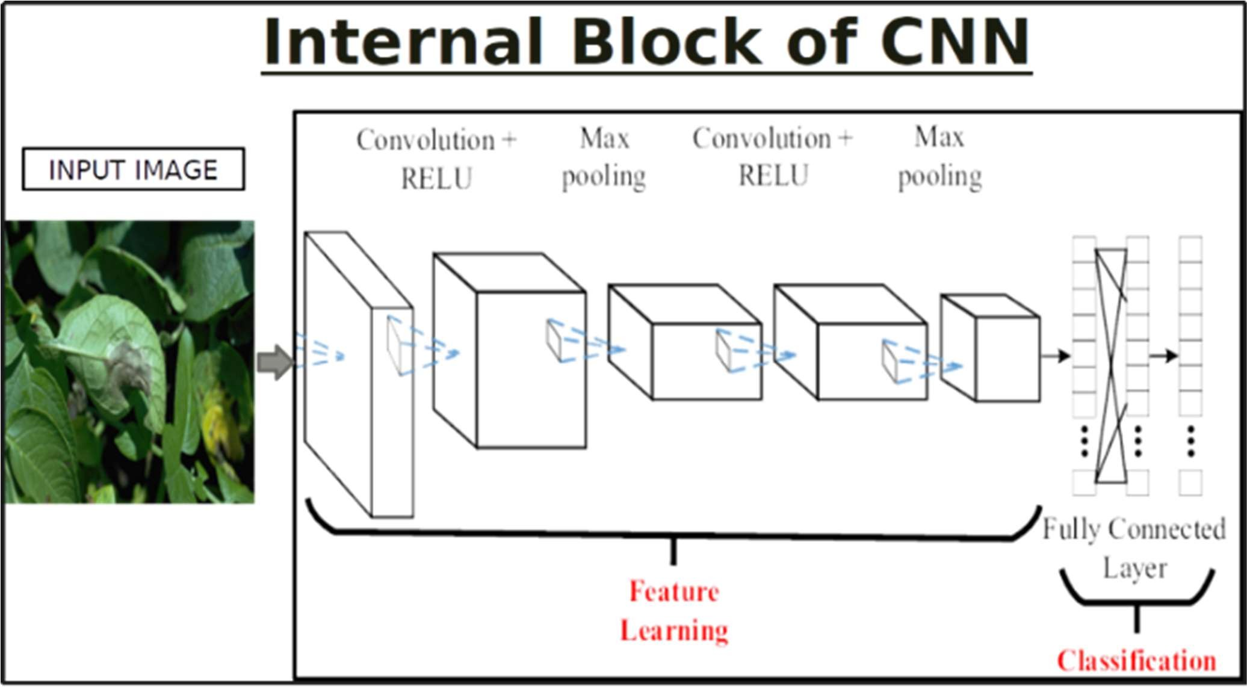

Fig 3.1 Basic CNN Structure

This network uses a 34-layer plain network architecture inspired by VGG-19 in which then the shortcut connection is added. These shortcut connections then convert the architecture into residual network.

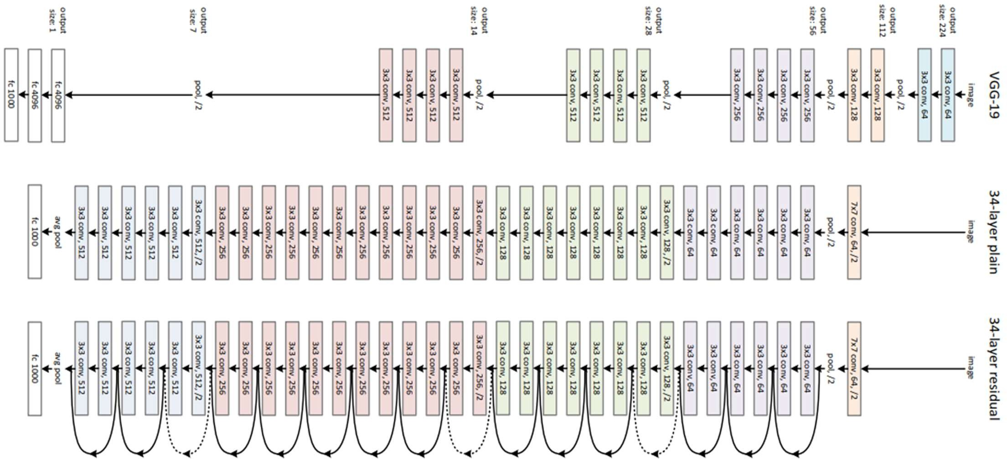

Fig 3.2 Layered structure of various algorithms

**4. System Requirements**

**4.1 Software Requirements**

* + - **Python development environment**
      * Python libraries like numpy, pandas, matplotlib, keras, tensorflow are being used to train and run the modules.
      * Other libraries include Firebase and Flask. Firebase connects the Google firebase platform to the python code to fetch the data received from sensors. matplotlib is also used to visualise the test data and training data.
      * Google Colab is used for training models using GPU. GPU for faster processing of the images datasets and extract features properly.
    - HTML, CSS and JavaScrript for creating user friendly User Interface.

# ANALYSIS MODELS

### 5.1 SDLC Model to be applied

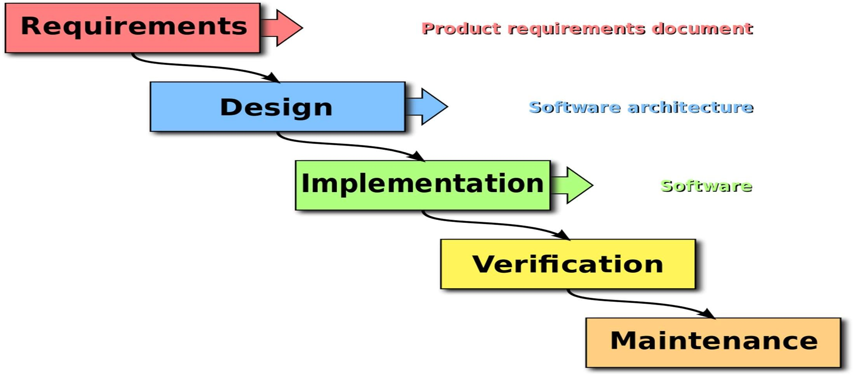

Fig 5.1 Waterfall Model

The SDLC Model we are going to use is the Waterfall Model.

* Waterfall Model is very simple and easy to implement especially for beginners
* It consists of systematic sequential approach which includes some phases.
* Each step is processed and completed at one time and avoids phase overlapping.
* All the requirements are known at the beginning it
* The requirements are compatible with all the key system stakeholders’ expectations.
* Our project don’t have enough customer involvement.

Hence waterfall model is best suited process model for our project.

### 5.2 System Architecture

Fig 5.2 System architecture

* 1. **System Design**

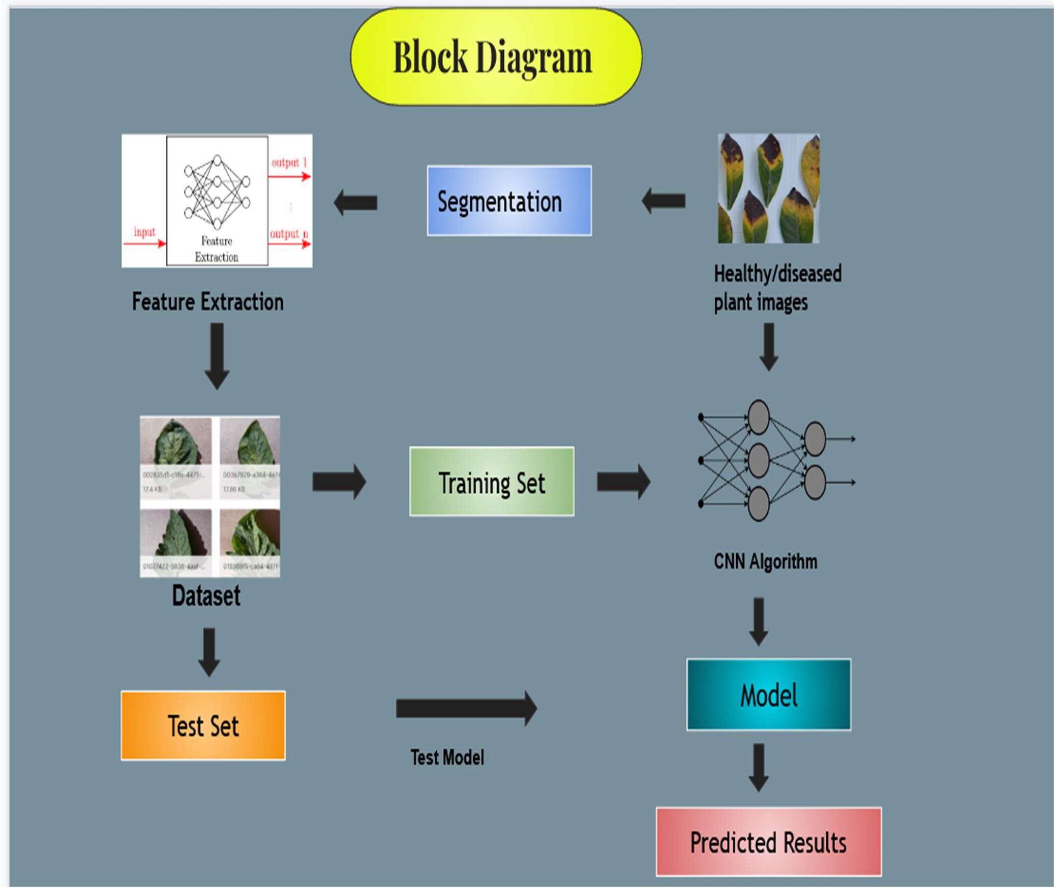

Fig 5.3 System Design

### USE CASE DIAGRAM

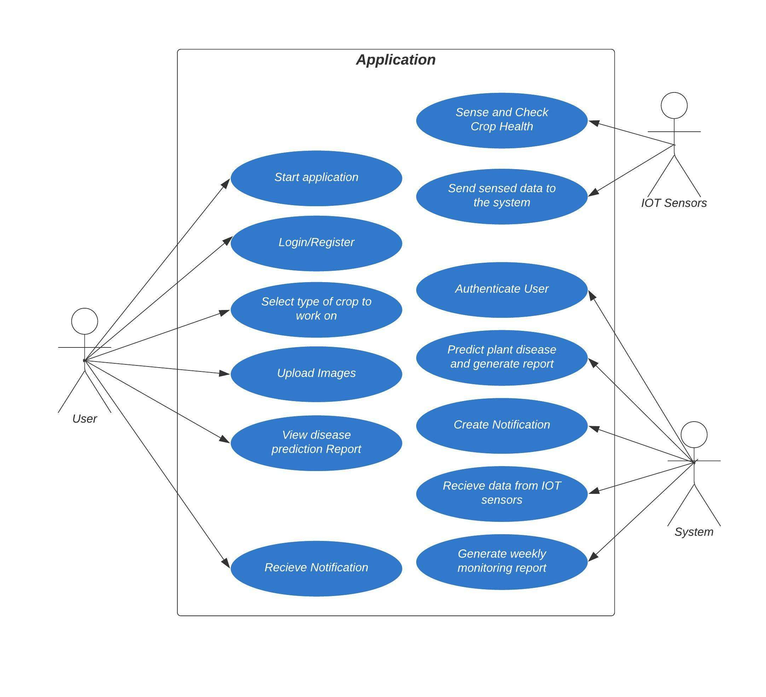

Fig 5.4 Use case Diagram

* 1. **ACTIVITY DIAGRAM**

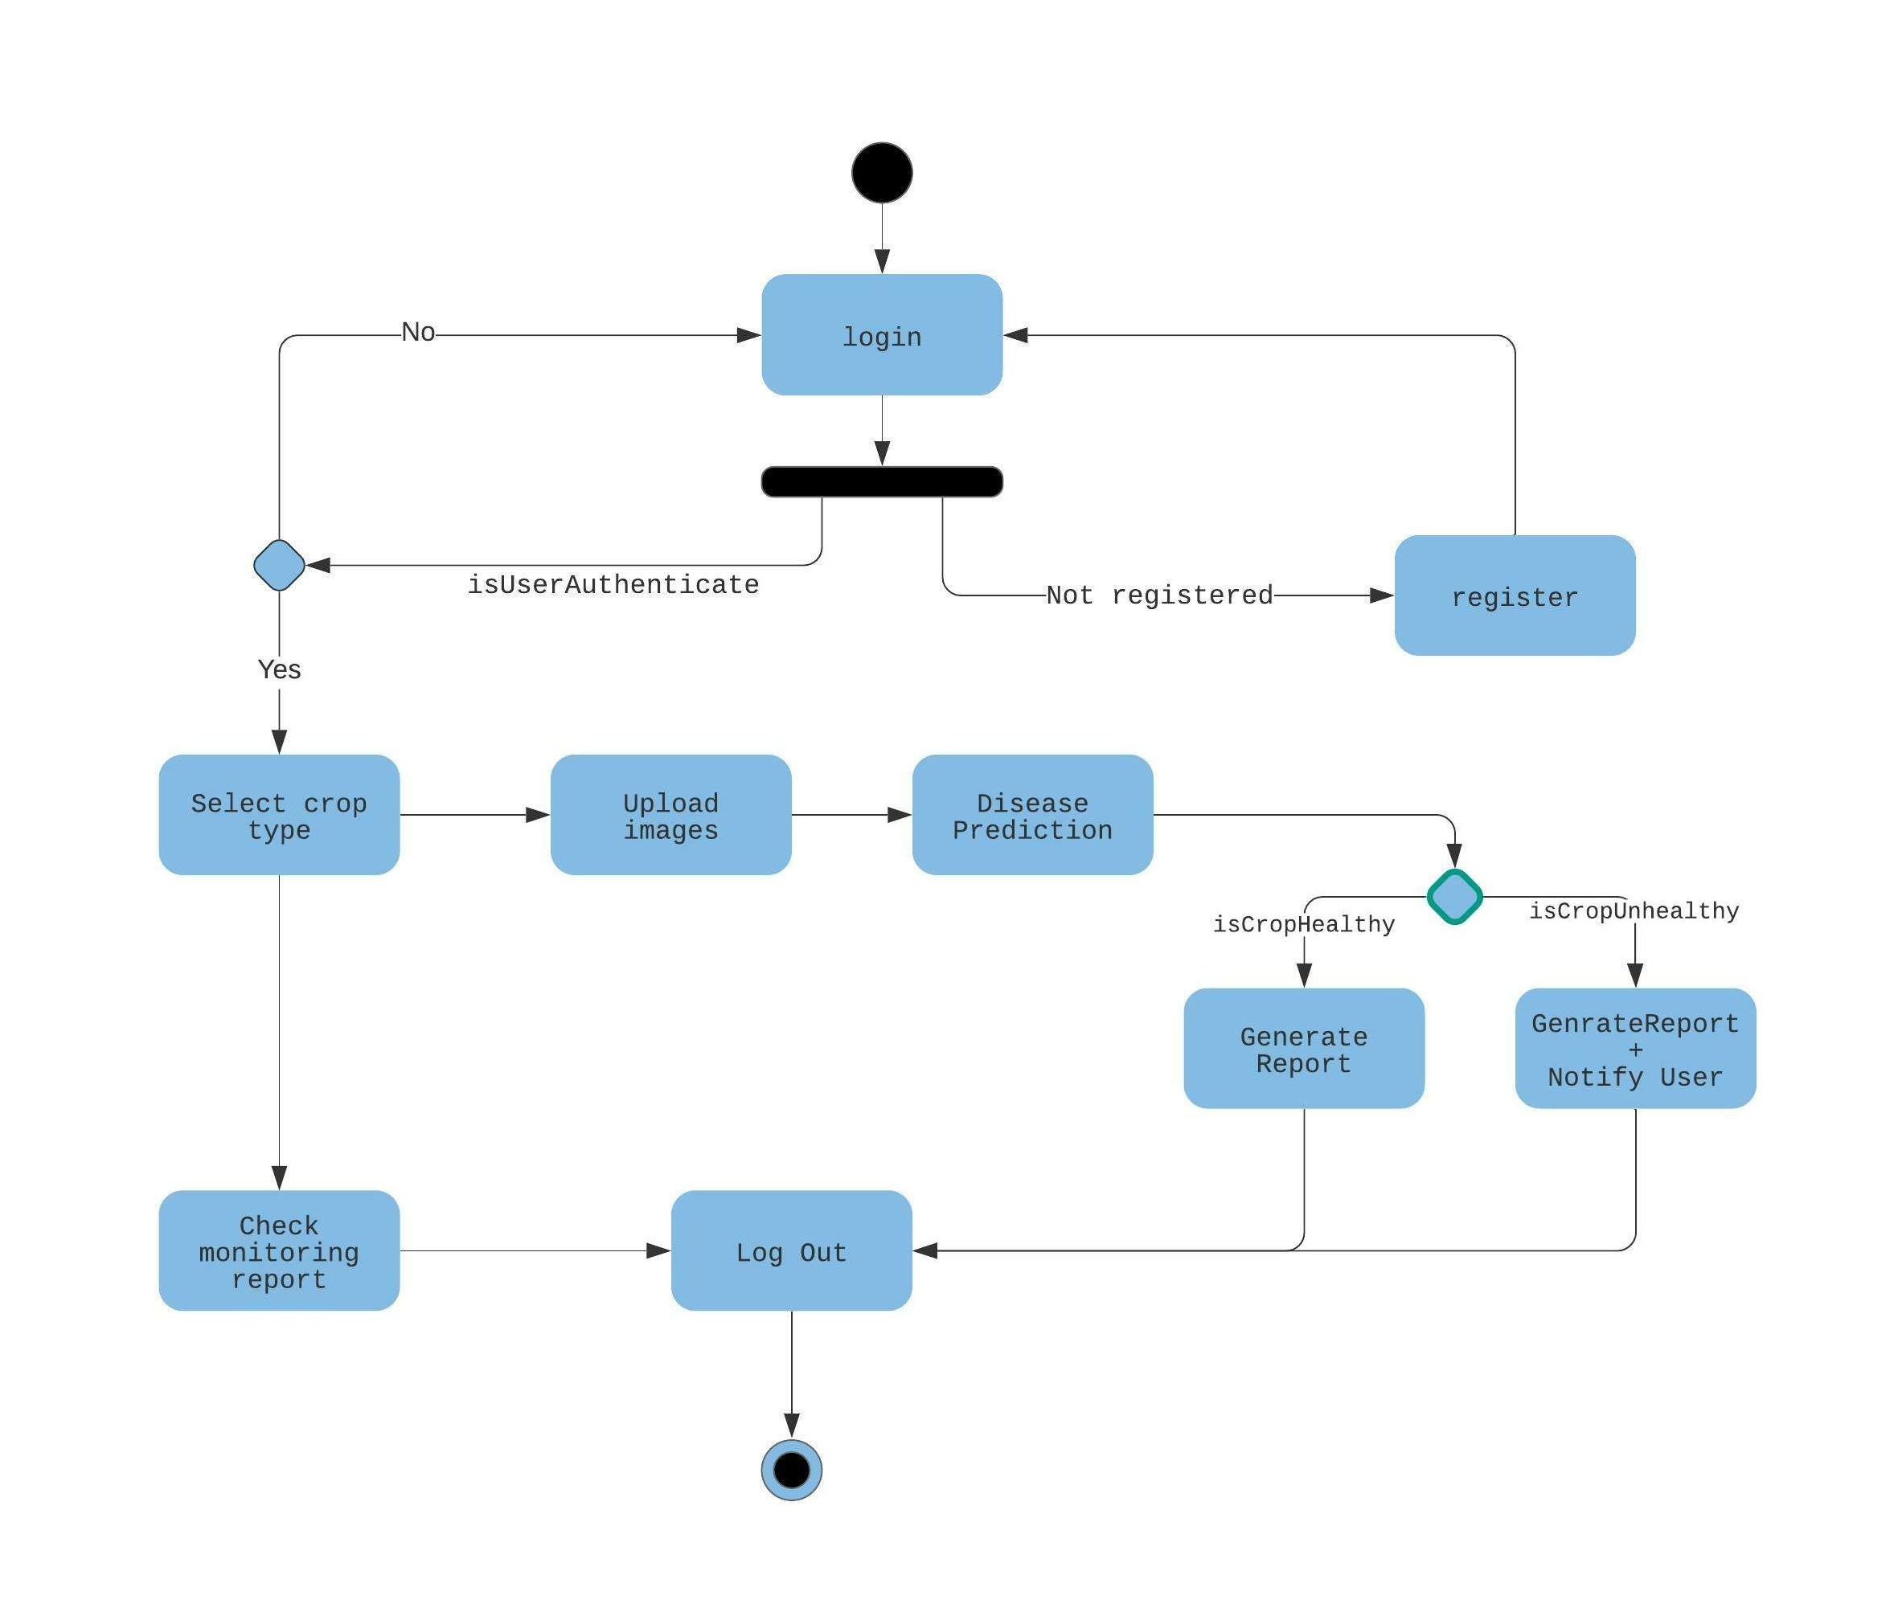

Fig 5.5 Activity Diagram

**5.6 ALGORITHMS**

* + - * **ResNet:**
      * To solve the problem of the vanishing/exploding gradient, this architecture introduced the concept called Residual Network.
      * In this network we use a technique called skip connections which skips training from a few layers and connects directly to the output.
      * It suggest that is instead of layers learning the underlying mapping, we allow the network to fit the residual mapping.

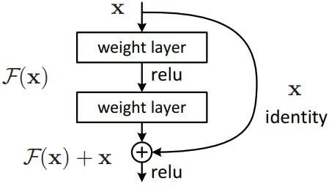

Fig 6.1 Skip Connections

The approach behind this network is instead of layers learn the underlying mapping, we allow network fit the residual mapping. So, instead of say H(x), initial mapping, let the network fit,

F(x) := H(x) – x which gives H(x) := F(x) + x.

The advantage of adding this type of skip connection is because if any layer hurt the performance of architecture then it will be skipped by regularization. So, this results in training very deep neural network without the problems caused by vanishing/exploding gradient. The authors of the paper experimented on 100-1000 layers on CIFAR-10 dataset.

There is a similar approach called “highway networks”, these networks also uses skip connection. Similar to LSTM these skip connections also uses parametric gates. These gates determine how much information passes through the skip connection. This architecture however has not provide accuracy better than ResNet architecture.

* + - **VGG NET**

VGG stands for Visual geometry group which is Neural Network Architecture. It has two versions VGG- 16 and Vgg-19. It is a pretrained CNN Model which defines the images according to shape, colour structure. When both the versions are compared VGG-19 is more accurate than the VGG-16 as the number of layers used are more.

VGG is an innovative object-recognition model that supports up to 19 layers. Built as a deep CNN, VGG also outperforms baselines on many tasks and datasets outside of ImageNet. VGG is now still one of the most used image-recognition architectures.

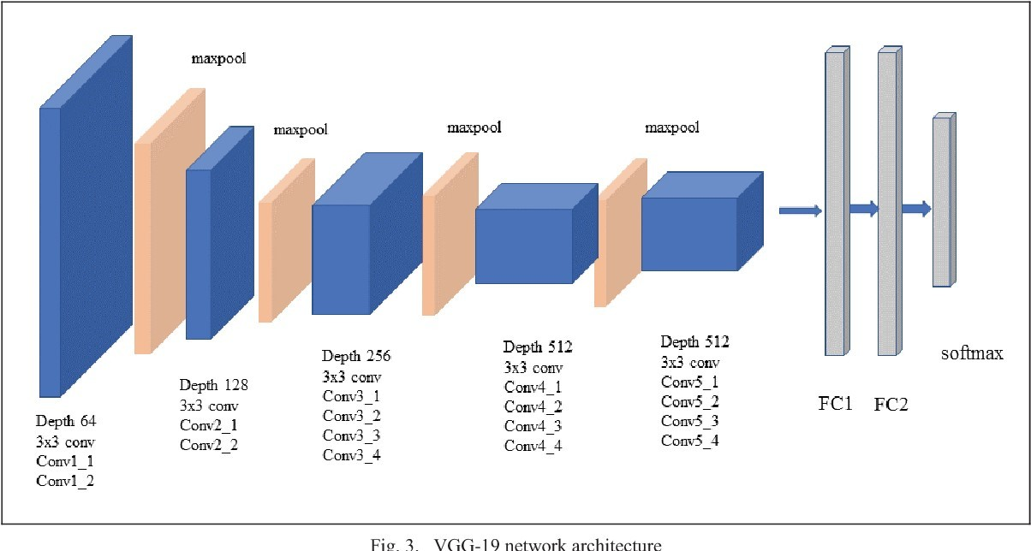

Fig 6.2 VGG19 Architechture

* **Input.** VGG takes in a 224x224 pixel RGB image. For the ImageNet competition, the authors cropped out the center 224x224 patch in each image to keep the input image size consistent.
* **Convolutional Layers.** The convolutional layers in VGG use a very small receptive field (3x3, the smallest possible size that still captures left/right and up/down). There are also 1x1 convolution filters which act as a linear transformation of the input, which is followed by a ReLU unit. The convolution stride is fixed to 1 pixel so that the spatial resolution is preserved after convolution.
* **Fully-Connected Layers.** VGG has three fully-connected layers: the first two have 4096 channels each and the third has 1000 channels, 1 for each class.
* **Hidden Layers.** All of VGG’s hidden layers use ReLU (a huge innovation from AlexNet that cut training time). VGG does not generally use Local Response Normalization (LRN), as LRN increases memory consumption and training time with no particular increase in accuracy.

# Other Specifications

### Advantages

**-**This webapp will be able to predict up to 38 different diseases.

-The growth of plants is monitored with the help of this application.

-It allows farmers to keep an eye on infected plants at various geographical areas under various weather conditions.

**-**The proposed system reduced chemical usage upto 33%.

### Disadvantages

**-**The webapp won’t be able to predict the disease without internet connection.

-There could be some enhancements done regarding plant’s health monitoring based on the features of crop leaves.

-Limited to disease prediction in selected plants only.

**-** Uneven illumination can cause errors in features extraction.

### Applications

* In smart farming to reduce the losses caused due to the inability to detect the plant diseases.
* Regularly monitor the crop health to take proper precautions during growth of crop.

1. **Results and Discussion**
   1. **Output of Model accuracy**

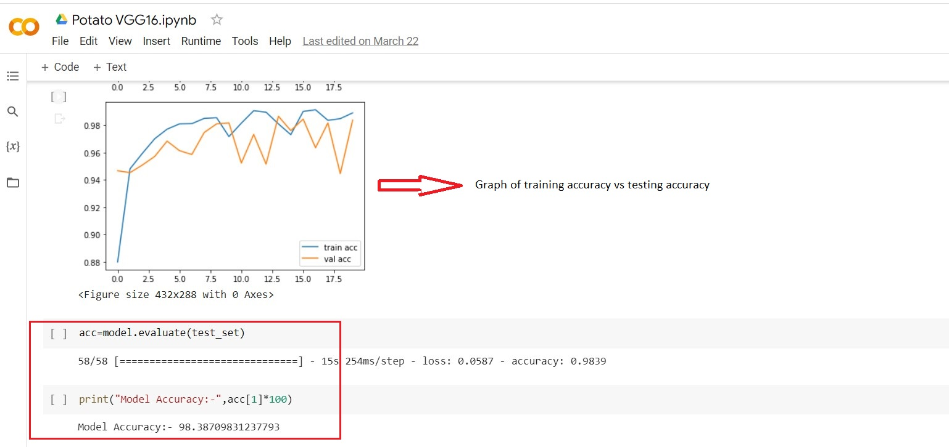

**7.2 GUI:-**

1. **Home Page**

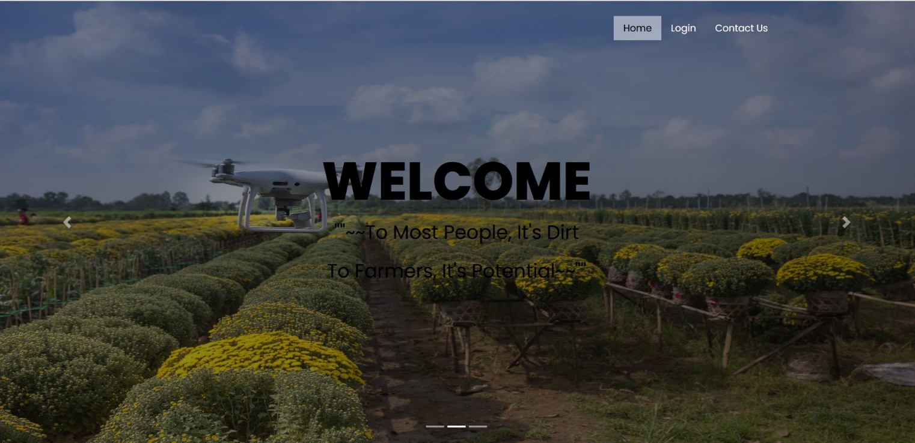

1. Login Page

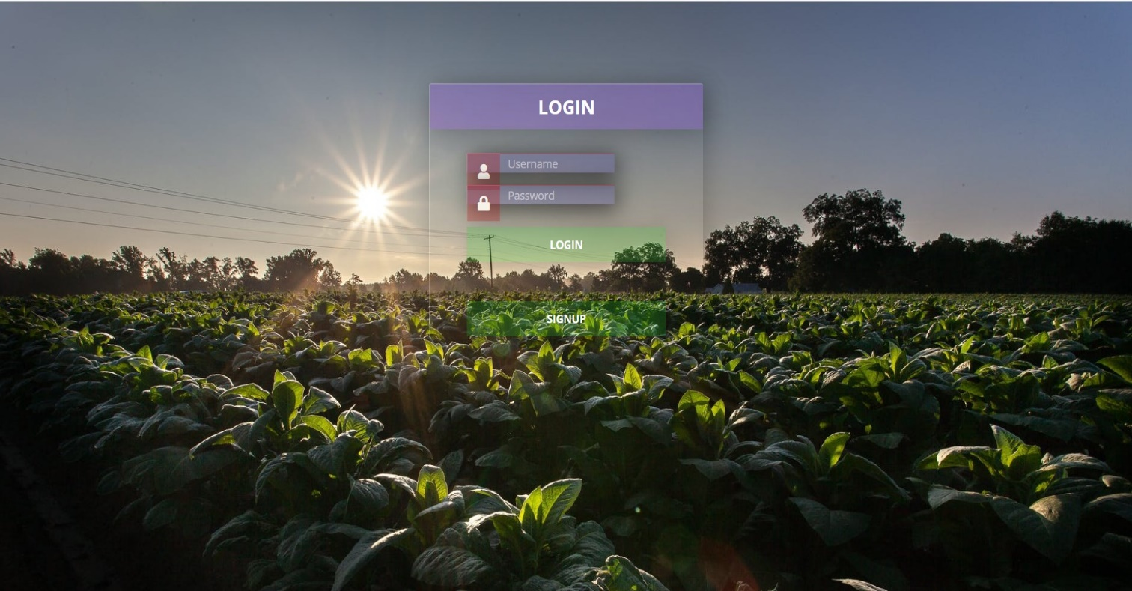

1. Upload Images Page



1. Predicted Results

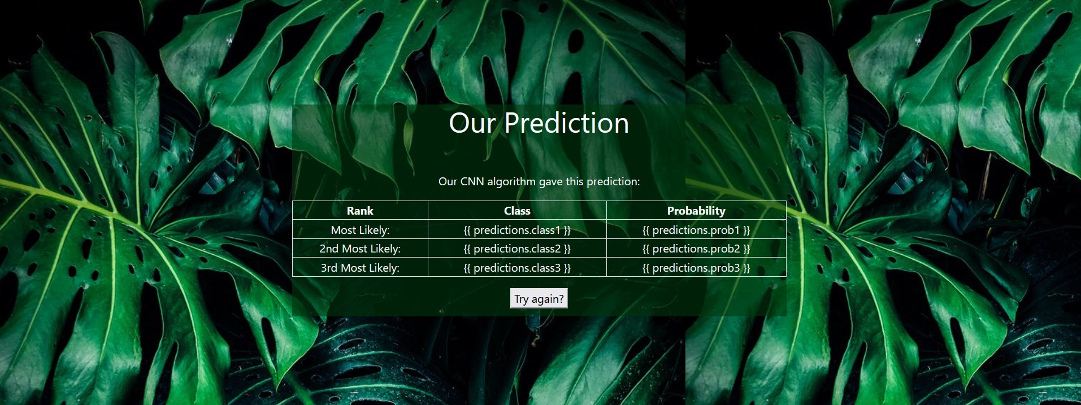

# Conclusion

* Back in old days only minimum handy tools were used for activities such as harvesting, sowing, etc.
* Today after thousands of years we have advanced immensely in terms of technology as well as lifestyle which led to growth in population and hence increased the demand for food supply.
* Due to this increase in demand of food supply it is necessary to reduce the yield losses using the smart agricultural techniques.

So the main motive is to identify and use various plant health monitoring and protection techniques. Plants' poor health conditions leads to lower productivity and fails to meet the increasing demands for food. This problem can be resolved using Deep learning applications. Variety of plant datasets have been used by the authors and they have obtained successful results with a good accuracy rate. Hence, it can be concluded from the survey that, plant health monitoring and protection techniques help in early detection of plant diseases, thus increasing the agricultural yield.

# References

* <https://www.bio-conferences.org/articles/bioconf/full_html/2020/01/bioconf_fies2020_00142/bioconf_fies2020_00142.html>
* -><https://towardsdatascience.com/crop-plant-disease-identification-using-mobile-app-aef821d1a9bc>
* V. Pallagani, V. Khandelwal, B. Chandra, V. Dhulapally, D. Das and S. P. Mohanty, "dCrop: A Deep-Learning Based Framework for Accurate Prediction of Diseases of Crops in Smart Agriculture," 2019 IEEE International Symposium on Smart Electronic Systems (iSES) (Formerly iNiS), Rourkela, India, 2019, pp. 29-33, doi: 10.1109/iSES47678.2019.00020.
* F. de Vita, G. Nocera, D. Bruneo, V. Tomaselli, D. Giacalone and S. K. Das, "Quantitative Analysis of Deep Leaf: a Plant Disease Detector on the Smart Edge," 2020 IEEE International Conference on Smart Computing (SMARTCOMP), Bologna, Italy, 2020, pp. 49-56, doi: 10.1109/SMARTCOMP50058.2020.00027.
* Eugeny V. Lutsenko, Valery E. Korzhakov and Valery I. Loko Kuban state agrarian University named after I. T. Tribilin, 350004 Krasnodar, Russia, Adyghe State University, 385000 Maykop, Russia.
* Junde Chen,Jinxiu Chen,Defu Zhang,Yuandong Sun,Y.A.Nanehkaran,School of Informatics, Xiamen University, Xiamen 361005, China,Spira Inc, Los Angeles, CA 90032, USA
* K.Padmavathi, and K.Thangadurai,“Implementation of RGB and Gray scale images in plant leaves disease detection –comparative study,”
* Y. Q. Xia, Y. Li, and C. Li, “Intelligent Diagnose System of Wheat Diseases Based on Android Phone,” J. of Infor. & Compu. Sci., vol. 12, pp. 6845-6852, Dec. 2015.